**REQ1**: ONLINE MARKET PLACE FOR “FOOD EXPERIENCE”: MAIN PAGE

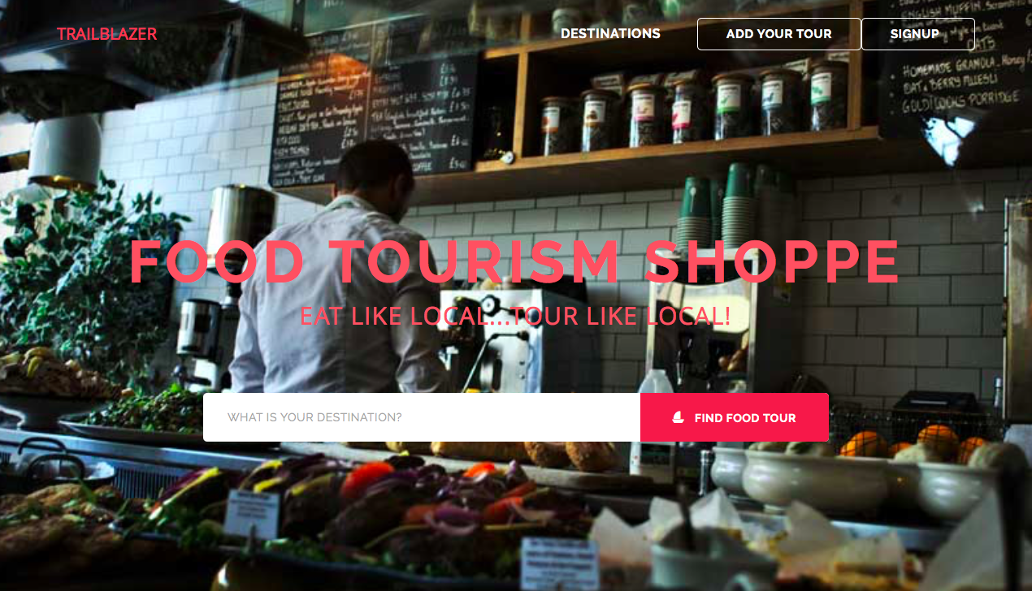

**REQ2**: CLICK “DESTINATIONS” THEN…THIS WILL DISPLAY ALL THE PRODUCTS IN ALL CITIES. HERE FOR EG: BOSTON HAS 730 PRODUCTS.

IT WILL ALSO DISPLAY STATS. VENDORS, CITIES, PRODUCTS, FOODIES REGISTERED.

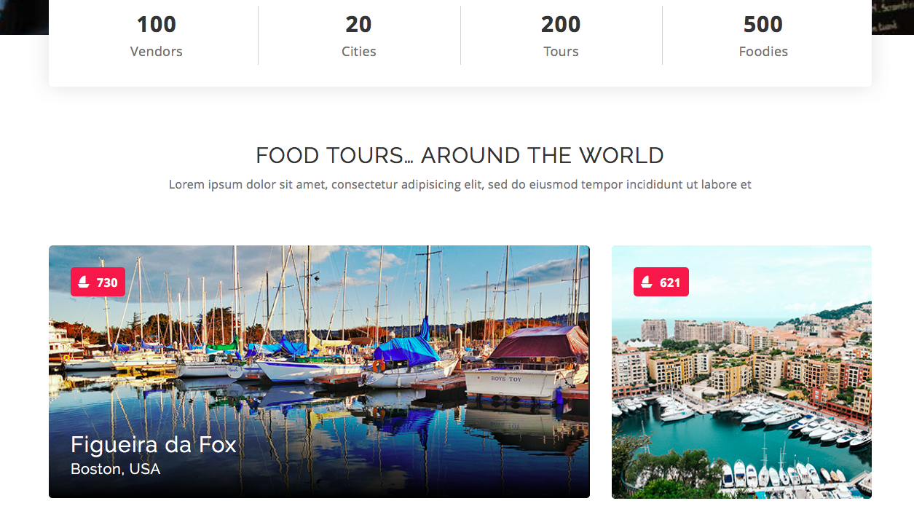

**REQ3**: CREATE YOUR TOUR/PRODUCT FOR ADDING A NEW TOUR/PRODUCT – OPENS A FORM FOR A REGISTERED USER. FORM WILL HAVE:

1. PRODUCT PLACE/CITY
2. PRODUCT NAME
3. PRODUCT DESCRIPTION
4. PRODUCT PICTURE (OPTIONAL)
5. PRICE

THIS WILL UPDATE DB WITH CITY KEY.

**REQ4**: SIGN UP: FOR NEW USER OR EXISTING USER. REGISTRATION WITH ID AND PASSWORD (GOOGLE OR FB ALSO FINE)

**REQ5**: SEARCHBOX: ENTER BOSTON, THEN PAGE SHOWS ALL BOSTON PRODUCTS (730, BUT ONLY FEW AT A TIME, CLICK “MORE” WILL SHOW MORE.

PS: SAME PAGE SHOWS UP IF BOSTON CLICKED FROM REQ2.

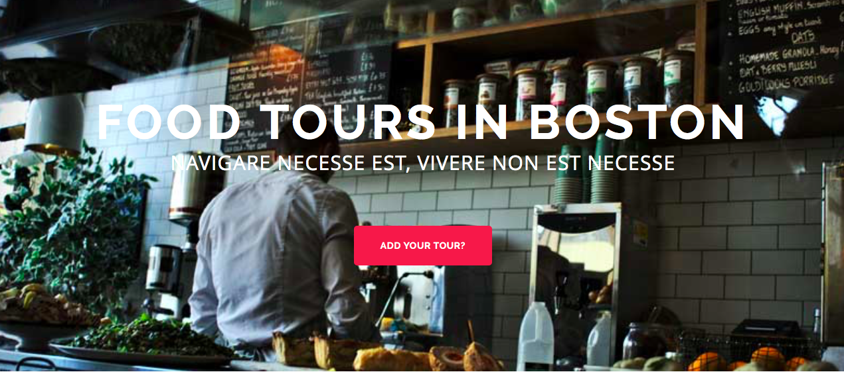

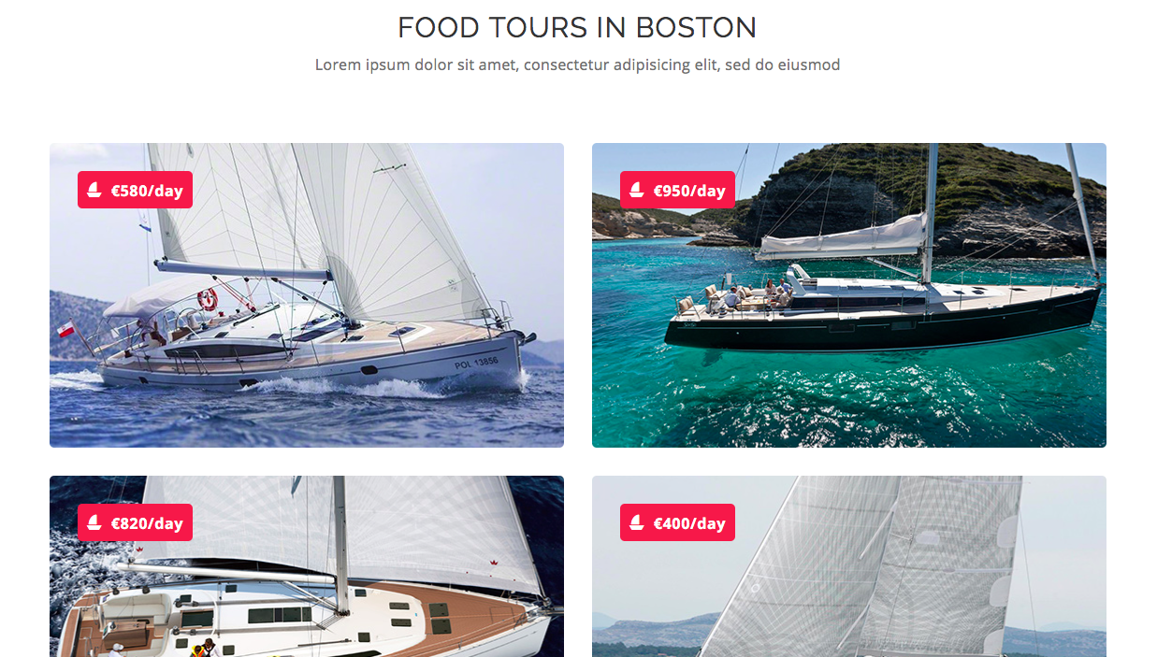

**REQ6**: SIGNED UP USER CAN CLICK EACH OF THE TOURS/PRODUCTS AND PROVIDE COMMENTS. THIS WILL UPDATE THE DB FOR THAT PRODUCT.

PS: IN REQ3 THE JSON DOC WILL HAVE FIELD FOR MULTIPLE COMMENTS. COMMENTS ARE NOT VIEWABLE TO EVERYONE.

**REQ7**: USE THE COMMENTS TO GET PRODUCT “SENTIMENTS” AND DISPLAY ON THE PRODUCT (INSTEAD OF RATINGS OR ALL COMMENTS) IN ADDITION TO PRICE.

PS: REQ3 THE JSON DOC WILL HAVE “SENTIMENT” FIELD. VIEWABLE TO ALL.

EG: http://blog.nycdatascience.com/student-works/sentiment-analysis-yelp-user-review-data/